REPORT OF HUMAN BELONGGINGS

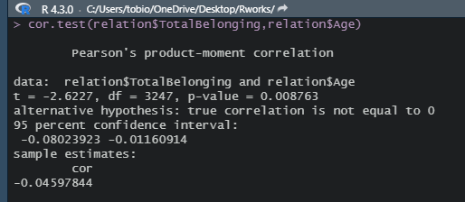

After running a correlation test between totalbelonging and age

The output provides:

1. An explanation of what is being compared, called data in the output table.
2. The *t*value: -2.6227 ; which indicate no significant of the
3. The degree freedom: 3247 (N-1) \* (C-1)
4. The p value: 0.008763
5. A statement of the alternative hypothesis the difference is not 0.
6. Confidence interval is not greater than our p value

Conclusion: We reject our result because our p value is not up-to confidence interval which is 0.05 and hence our null hypothesis is rejected. So we can say there is relations to friendship